The Case of
Liam Johnson

Using separating techniques to solve a crime

Alison Graham
Paul Redmond
Teachers notes
The case of Liam Johnson
____________________________
Syllabus links:
Junior Certificate Science: 2A2 Separating substances using filtration, evaporation, distillation and paper chromatography

Equipment required:
Per group: Bunsen burner, gauze, pyrex beaker/evaporating dish
Beaker, stirrer, filter funnel, filter paper
Chromatography paper, beaker, wooden splint to support paper
This activity works well in groups of 3- each person does one of the tests and they pool their results to come up with the answer

What you need to do in advance:
Photocopy sheets needed
Lung water sample: tap water
Tea sample: some cold tea
Sugar sample: some dark brown sugar with powdered carbon/ iron filings added

Expected results:
Lung water sample: heating does not give salt
Tea sample: chromatography does not show visible contamination
Sugar sample: shows another substance when sugar dissolves

Suggested answers to questions:
- Lung sample is not salt water so Liam was not drowned at sea- but may have drowned in swimming pool. (Discussion point: Negative results can be very important in giving information!)
- Tea sample shows no contamination (Discussion point: limitations of this method, visible contaminants revealed only- in Forensic labs separation of components of the mixture is followed by chemical detection)
- Sugar sample does show contamination.
- It is important that the students realise that there are often several ways to interpret results and it is important that scientists are able to think laterally of possible explanations! The evidence suggests that Liam was poisoned and/or drowned in the pool but then moved to the sea .
- What is the contamination in the sugar? Who else was in the house at the time? etc etc
- Student worksheet
The Case of Liam Johnson

The crime
This is a newspaper cutting about the discovery of a body at Howth Head.
BODY FOUND AT HOWTH HEAD
The body of Liam Johnson was pulled from the sea yesterday evening at Howth Head. Forensic scientists have placed time of death as sometime between 6 and 9 pm the previous evening. His grieving wife and daughters were too distraught to talk to the press but it is believed that his once booming business was now in some financial difficulties
Irish Independent, May 7th 2009
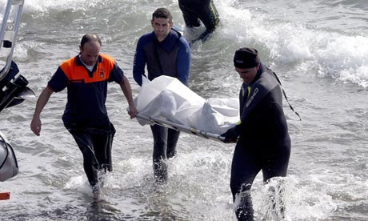

Although initially it looks like a tragic drowning accident the Gardai are not convinced that all is as it seems.

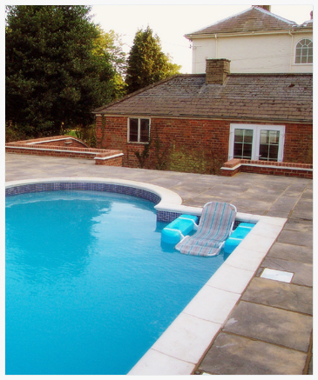
The Forensic team have collected samples at the post mortem and at the home of Liam Johnson where they found his towel near the pool ……

…and a table with a used tea cup, tea pot and brown sugar.


You are the Forensic Scientist appointed to investigate the samples collected which are
- a sample of water from the lungs of Liam Johnson
- a sample of tea from the teapot
- a sample of sugar from the sugar bowl

What you need to know!

You have learnt a number of separating techniques which will be very useful to you here! You will have to think carefully about which ones you need to use.
evaporation
filtration
chromatography
distillation
magnetism

What you need to do to solve the crime!

Decide what tests to carry out on your samples to find out
- Did Liam Johnson die from drowning in the sea?
- Is there any evidence that the tea is contaminated with another substance?
- Is there any evidence that the sugar is contaminated with another substance?

Record your findings carefully on the chart below

Sample | Method used | Results | Conclusions
(a) water from the lungs of Liam Johnson
(b) the tea in the teapot
(c) the sugar in the sugar bowl
What have you found out?

- Did Liam Johnson drown in the sea? Outline the evidence for your answer.
………………………………………………………………………………………………………………………………………………………………………………………………………………………………………………………………………………
- Is there any evidence for contamination of the tea by another substance. Outline the evidence for your answer.
………………………………………………………………………………………………………………………………………………………………………………………………………………………………………………………………………………..
- Is there any evidence that the sugar was contaminated by another substance. Outline the evidence to support your answer.
………………………………………………………………………………………………………………………………………………………………………………………………………………………………………………………………………………
- What do you think happened in this case?
……………………………………………………………………………………………………………………………………………………………………………………………………………………………………………………………………………………………………………………………………………………………………………………………………………………………………………………………………
- What further evidence or tests would need to be collected to prove that your ideas are correct?
………………………………………………………………………………………………………………………………………………………………………………………………………………………………………………………………………………………………………………………………………………………………………….

